**Day 43:**

**Demo AWS Project**

Clone this repo: <https://github.com/VarunTej06/AWSDemo>

Create an EC2 instance with RedHat AMI/ Any other AMI. 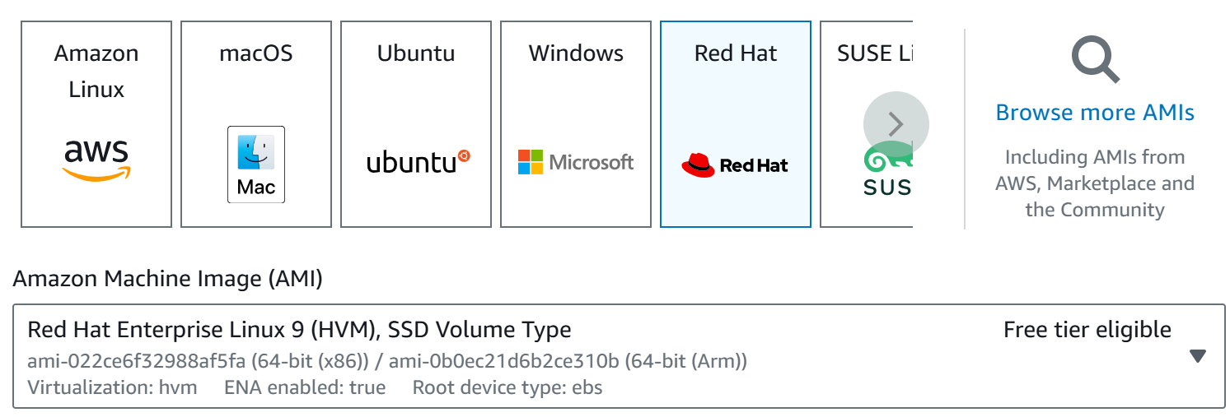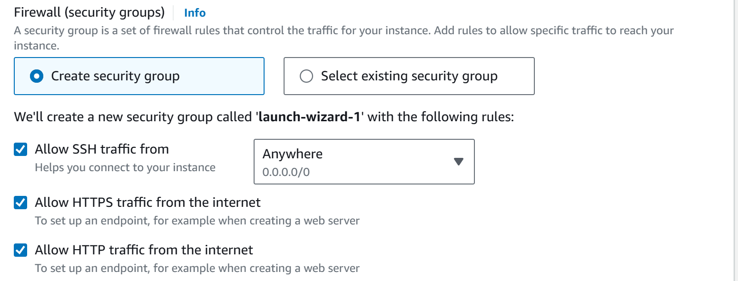Connect to the instance: Since, AMI used is Amazon Linux, install git: 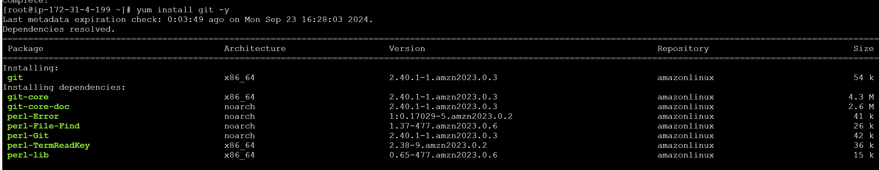 Now clone the repo into this EC2 instance. 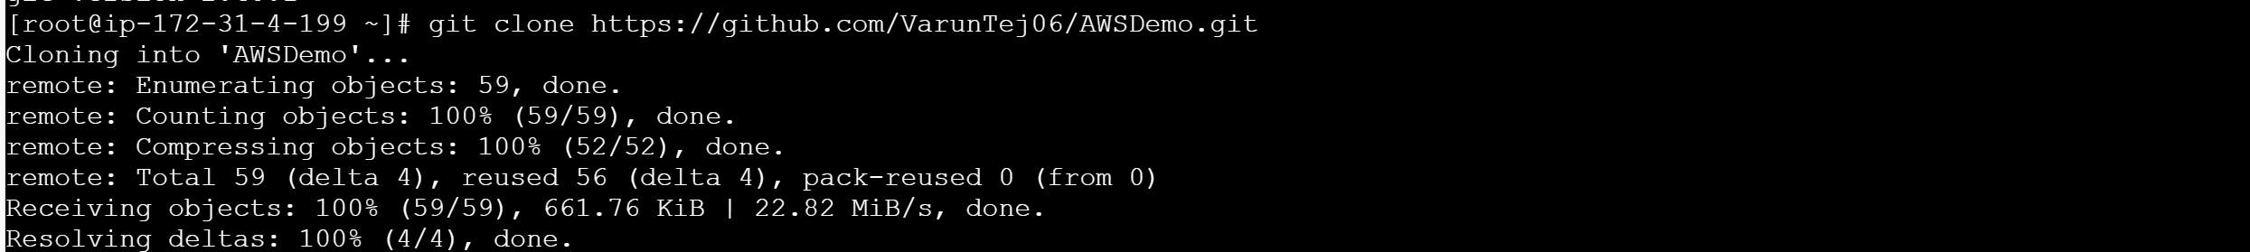

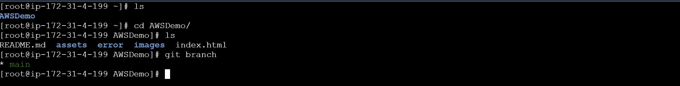Now, we have the application code. We want to host it and any request coming in should be served. But there should be an application that is listening to the requests and serve them. We need to install HTTPD (apache web server) used to access the application we developed. 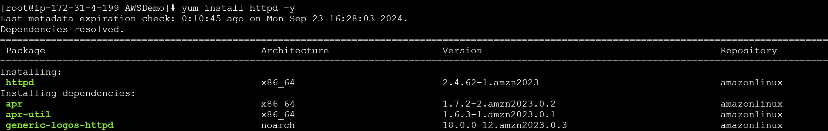

For hosting the website apache webserver is installed but it will only serve the websites that are in “/var/www/html”. So, we need to copy all the files to that location. 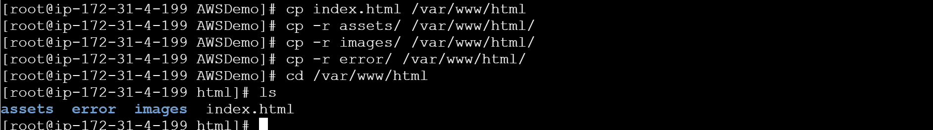Now try to access you application using your EC2 instance IP. This HTTPD service will redirect all the http or https requests to this application.

Copy the public IP and paste it in new tab of any browser. 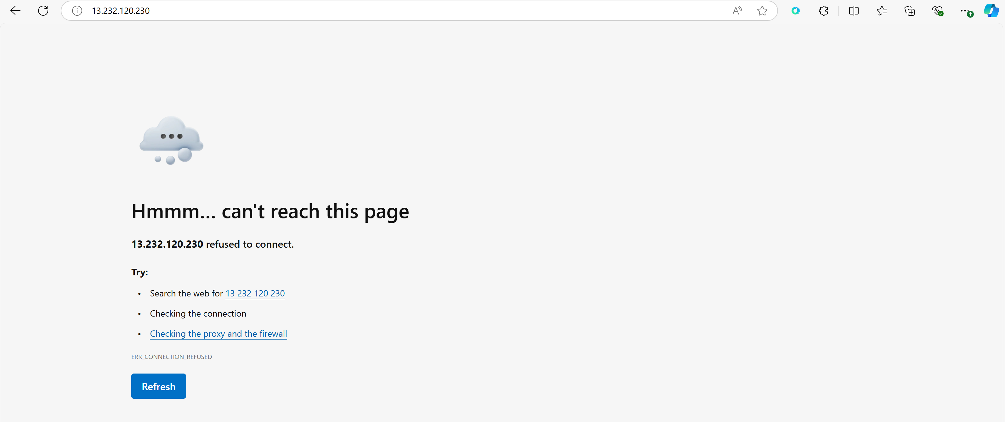The service HTTPD is not up and running. 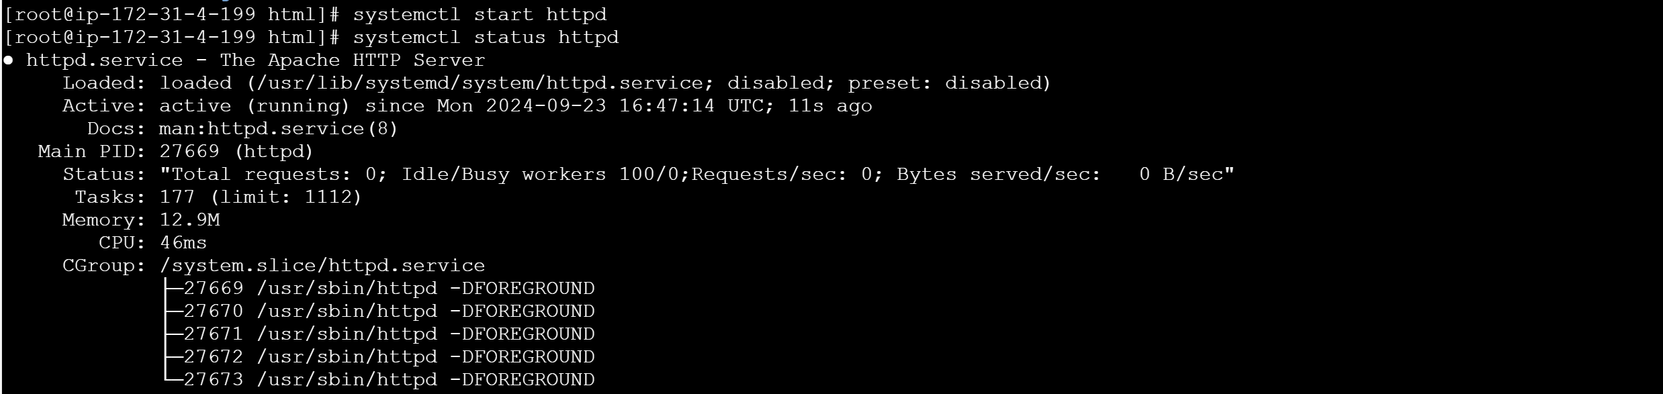

Now, refresh the page our application is available live now:

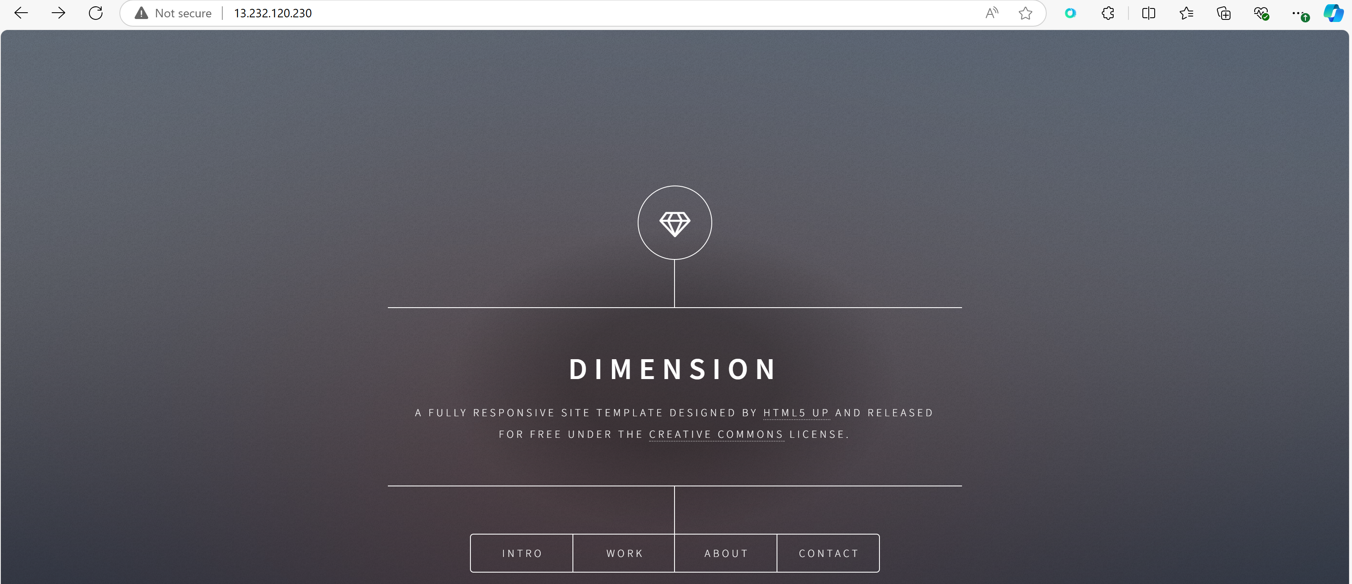Application is up and running. All the other forms are also working: